Desgining The SpiderBot

line 1: Asadujaman Nur   
line 2: *Electronic Engineering*  
line 3: *Hochschule Hamm-Lippstadt*line 4: Lippstadt,NRW,GERMANY  
line 5: Asadujaman.nur@stud.hshl.de

*Abstract*—This document explain the designing process on developing the rescue robot “SpiderBot”

Keywords—Rescue robot,Spiderbot,RobotSpider,Lifesaver

# Introduction (*Heading 1*)

Behind every Great product comes the Design. and a great design defines a great product regarding its looks and functionality, designing the spiderbot took a lot of creative thinking and effort. like the name the robot was made like the shape of Spider. The reason behind it was they way the spider was built. The shape and structure give the spider mobiliy and flexibility during movement. The same it make them strong and fierce. And this is what we needed for our robot. Since our robot have to operate in unfavorable environment, the design will help us to operate there easily. Our design not only allow our spiderbot to walk on the land, it allows it to move on the water aswell.

//As mention on the requirement part our final spiderbot version will be able to do a lot of stuff. But for prototype we decided to spare some of the features, like 360° camera, Biometric sensors, communication devices ect, however it doesn´t make our robot less effective which we discuss later on.

# Concept Design

## Diagram Description automatically generatedConcept Design

The 360° camera were designed to monitor the surrounding. And an operator could use the camera to project immersive experience while control the robot manually.

Like the spider, our design share some common features.  
like 6 legs were designed to give maximum efficiency and minimum power consumption while moving

The front were design to host the vital measurement, display and communication system.

The turbine gives fastest mobility to move on water using water jet technology. The main turbine were design to provide thrust and smaller turbines were designed to provide movement under and on the water.

The arms were design to grasp and push object if necessary.

And the body was designed to chamber most of the electronice component(which we will learn about later) and meant to have some room for emergency supplies like medicine or water while being completely water tight.

## Changes to the Design

As mention on the requirement part our final spiderbot version will be able to do a lot of stuff. But for prototype we decided to remove and add some of the features, like 360° camera, Biometric sensors, communication devices, the arm and small turbines and ability to dive under water were removed. However a boat shape body were added to provide the ability to float and a different control method were added to control the movement on the water

Later on we will only talk about the features that we are implementing on the prototype not the final version of our spiderbot

# 3d modeling

To Make 3d model of our spiderbot we took the help of solid works. And this is the rough sketch we followed to to make our model

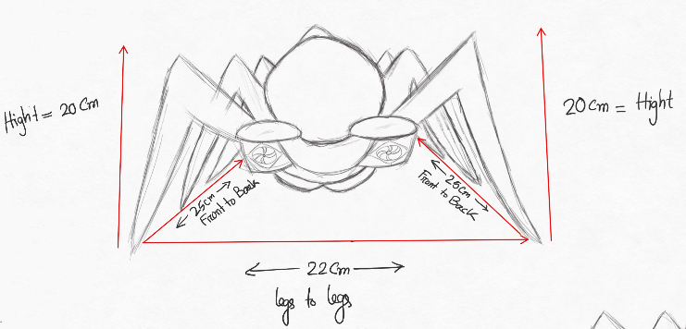

We followed the dimension for the overall size of our spiderbot and we followed the 1:10 requirement for the 3d modeling

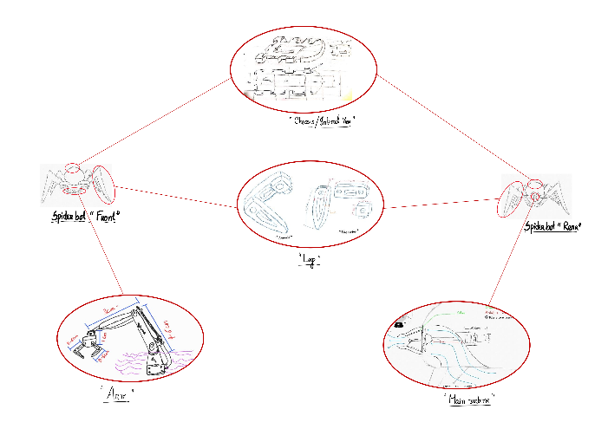

And for the individual part this dimension were followed. Just to mention the arm was the finial part we decided to remove. But we are going to leave the arm here so that gives a better contrast on the dimension idea.

## Legs

Following the design we were able to recreate the 3D model in solidworks.

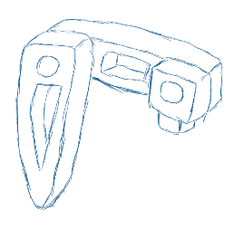 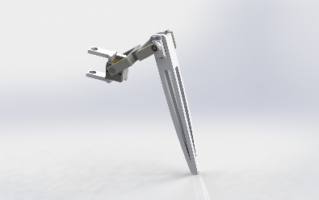

## Body/Chassis

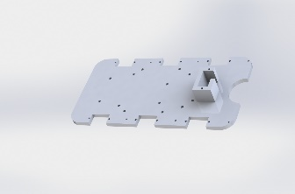

The main body and the chassis is the center point of the SpiderBot. It were designed in such a way, so that it can host most of the electronic components and the body acts as a protective shield for the environment. Like we mentioned earlier, some part were added, the par like boat shape is the part has been added to give the spiderbot the ability to flow through water

## Turbine

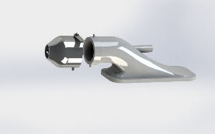

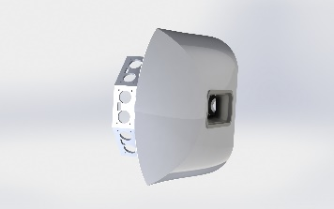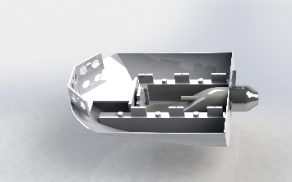

The same principals were followed to design and 3D model to create the turbine. Later on it were attached to the body. So it prevent water from coming inside, thus water-sealed!.

## Final Model for prototype

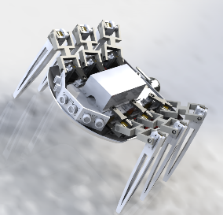

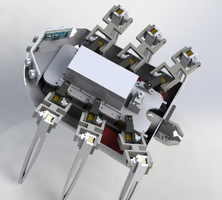

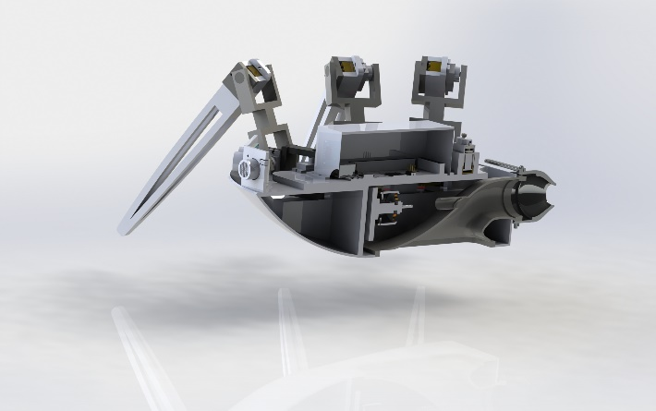

So, finally with some addition and subtraction the final version of our spiderbot will look like the picture above. Here we have 3 different view from different prospective.

# Materials

One of the biggest aspect of designing is to choose the right materials for the product. Therefore to 3D print our spider bot prototype, our primary choice of material is plastic however for the final version of our spiderbot we will use different materials based one the body parts. for example:

* For the body our primary choice is mixture of carbon fiber and Stainless steel which will provide strength and durability to our robot
* However to add grip on the legs some rubber tip will be added on the tip of the legs. Thus it will act like shoes for the robot and like the shoes it will be easy to replace therefor it will add extra protection aswell as easy maintainability

# Tools

To help us archive the great design for our spiderbot some tools were used.

The list of these tools will be mention below.

* Concepts: an Drawing software which was used to design the concept for spiderbot
* Solidworks was used to build our 3D prototype
* CURA was used to do masurements for 3D printing

By combining the tools and all the skills we have spiderbot came to live from our imagination.